**DAILY ONLINE ACTIVITIES SUMMARY**

|  |  |  |  |  |  |  |  |  |
| --- | --- | --- | --- | --- | --- | --- | --- | --- |
| **Date:** | **23/05/2020** | | | | | **Name:** | **Hanan Saleem Baji** | |
| **Sem & Sec** | **4th SEM 'A' Section** | | | | | **USN:** | **4AL18CS024** | |
| **Online Test Summary** | | | | | | | | |
| **Subject** | | **Data Communication** | | | | | | |
| **Max. Marks** | | **30** | | **Score** | | | **28** | |
| **Certification Course Summary** | | | | | | | | |
| **Course** | **1.Python In Machine Learning** | | | | | | | |
| **Certificate Provider** | | | **1. Great Learning Academy** | | **Duration** | | | **1. 30 min** |
| **Coding Challenges** | | | | | | | | |
| **Problem Statement:** 1. Write a C Program to generate first N Triangular Numbers (Where N is Read from the Key board).  For example | | | | | | | | |
| **Status: completed** | | | | | | | | |
| **Uploaded the report in Github** | | | | | **Yes** | | | |
| **If yes Repository name** | | | | | <https://github.com/saleemhananbaji/C-coding> | | | |
| **Uploaded the report in slack** | | | | | **Yes** | | | |

ONLINE TEST DETAILS: Online test was conducted on the first and second module of Data Communication. Test contains 30 questions of 1 Mark each. I have scored 28 Marks.

Snapshot:

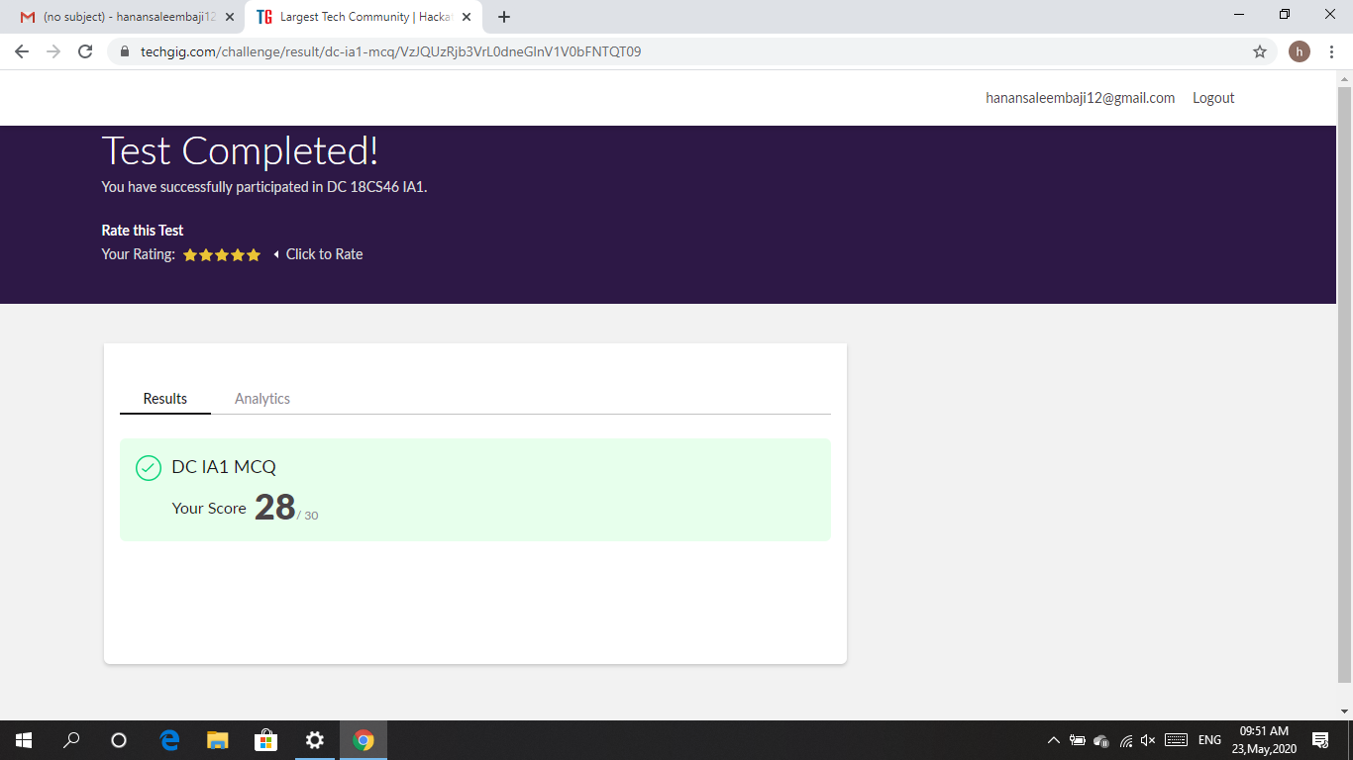

Certification Course Details: I have completed watching explanation of the Python course through videos. Today I took up the quiz test. This test contains 10 questions of 1 mark each. I have scored 8 marks.

Snapshot:

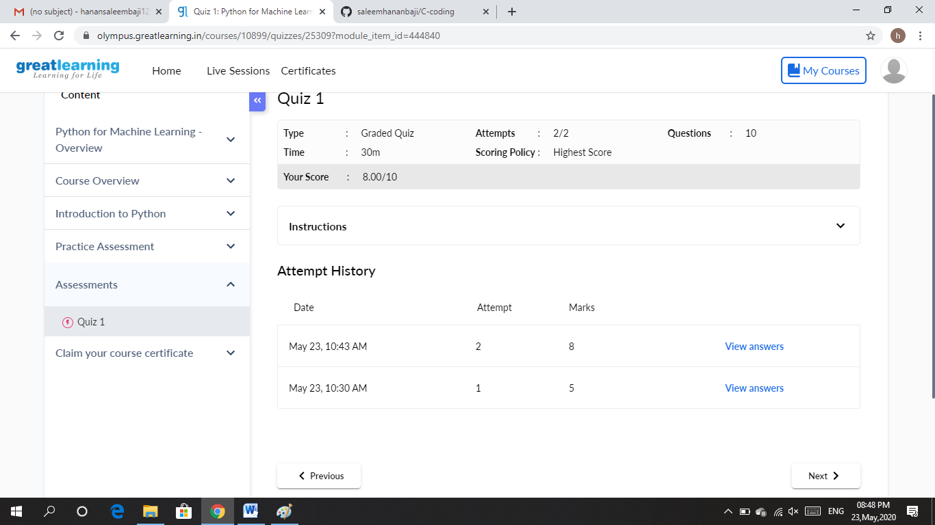

CODING CHALLENGES DETAILS: Problem statements

1. Write a C Program to generate first N Triangular Numbers (Where N is Read from the Key board).

Solution : Uploaded it in github

Snapshot:

